

24 March 2025

Livhu and Musa Enterprise (Pty) Ltd
Dear Sir/Madam

RE: Livhu and Musa Enterprise (Pty) Ltd – CAR178869

We confirm that Guardrisk Construction and Engineering Underwrites that we are on cover for the above-mentioned client subject to terms and conditions of the policy:

Contract Description: Tender For the Appointment of Service Providers for The Hire Of Mobile Drinking Water Tankers (Trucks) With The Loading Capacity Of Between 10 000 To 15 000 Litres Of Water For The Supply In The Informal Settlements In The City Of Tshwane: Three (3) Year Period: As And When Required: With Effect From 15 February 2025 Or Nearest Date.

Estimated Contract Value: R 35 000 000.00

Public Liability: R 5 000 000.00

Contract Period: 36 Months Start Date: 25/03/2025
End Date: 28/02/2028

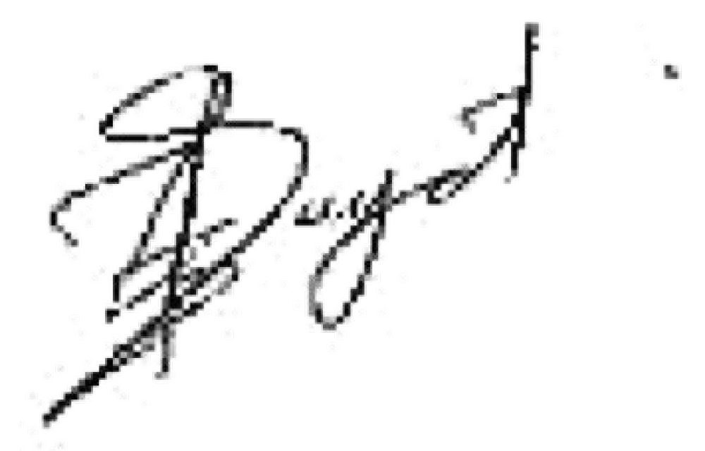
Regards

